Java TreeMap class

* A TreeMap contains values based on the key. It implements the NavigableMap interface and extends AbstractMap class.
* It contains only unique elements.
* It cannot have null key but can have multiple null values.
* It is same as HashMap instead maintains ascending order.

Hierarchy of TreeMap class:

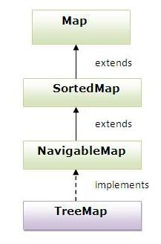

Example of TreeMap class:

1. **import** java.util.*;
2. **class** TestCollection15{
3. **public** **static** **void** main(String args[]){
5. TreeMap<Integer,String> hm=**new** TreeMap<Integer,String>();
7. hm.put(100,"Amit");
8. hm.put(102,"Ravi");
9. hm.put(101,"Vijay");
10. hm.put(103,"Rahul");
12. **for**(Map.Entry m:hm.entrySet()){
13. System.out.println(m.getKey()+" "+m.getValue());
14. }
15. }
16. }

[**Test it Now**](http://www.javatpoint.com/opr/test.jsp?filename=TestCollection15)

Output:100 Amit

101 Vijay

102 Ravi

103 Rahul

What is difference between HashMap and TreeMap?

|  |  |
| --- | --- |
| 1) HashMap is can contain one null key. | TreeMap can not contain any null key. |
| 2) HashMap maintains no order. | TreeMap maintains ascending order. |